**🌟 Project Report: EdTech Customer Subscription Churn & Retention Analysis 🌟**

**1. Project Overview**

This project focuses on analyzing churn patterns and customer retention within a fictional EdTech subscription platform. I generated a realistic synthetic dataset of 1,000 customer records to simulate real-world business challenges. The aim was to identify churn drivers, measure overall churn rates, and build a user-friendly dashboard to support data-driven decision making.

**2. Objectives**

✅ Understand customer churn behavior  
✅ Identify high-risk segments (e.g., plans, regions)  
✅ Monitor customer growth over time  
✅ Present actionable recommendations to improve retention

**3. Data Preparation**

* Created a synthetic dataset with fields including Customer ID, Join Date, Cancel Date, Plan Type, Region, Country, and Auto Renew status
* Cleaned null values, especially missing Cancel Date for active customers
* Engineered a churn flag based on the Cancel Date column
* Validated data for consistency and accuracy

**4. Exploratory Data Analysis (EDA)**

Using Python (Pandas and Seaborn), I performed EDA to:

* Profile customer segments
* Examine churn rates by Plan Type and Region
* Analyz the impact of Auto Renew on churn
* Explore time-series trends in new customer acquisition

**5. Dashboard Development**

Using Power BI, I designed a professional, interactive dashboard with the following key elements:

* **KPIs:**
  + Total Customers
  + Active Customers
  + Churned Customers
  + Overall Churn Rate
* **Visuals:**
  + New Customers Over Time (line chart)
  + Churn by Plan Type (bar chart)
  + Churn by Region (bar chart)
  + Auto Renew distribution (donut chart)
  + Detailed customer table
* **Filters / Slicers:**
  + Plan Type
  + Region
  + Year

Advanced DAX measures were applied to calculate dynamic KPIs and time-based trends.

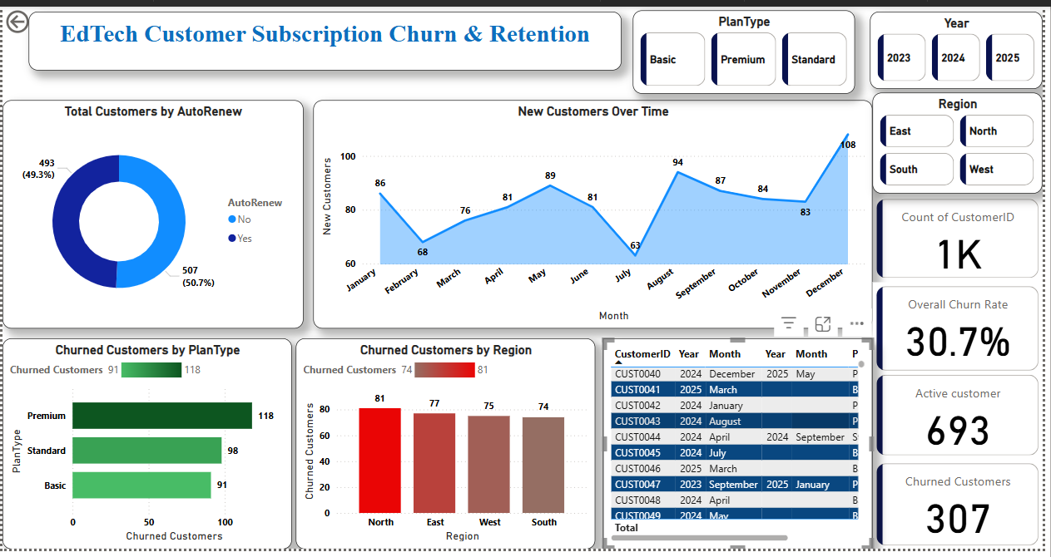

**6. Key Insights**

🔹 Around 30% of customers churned, with Basic plan users showing higher churn rates  
🔹 Customers without auto-renewal showed higher churn likelihood  
🔹 New customer signups showed seasonality, peaking in August and December  
🔹 Churn varied across regions, with the North region showing higher churn

**7. Recommendations**

✅ Implement loyalty or discount programs for Basic plan subscribers  
✅ Encourage auto-renewal through targeted incentives  
✅ Monitor seasonal signups to plan proactive retention strategies

**8. Tools & Technology**

* Python (Pandas, Seaborn)
* Power BI (Data modeling, DAX, visualization)
* Excel (for data verification)

**9. Conclusion**

This project demonstrates advanced skills in data cleaning, exploratory data analysis, DAX measure building, and visualization storytelling for a subscription-based EdTech scenario. The Power BI dashboard is portfolio-ready and provides a clear example of actionable data-driven recommendations